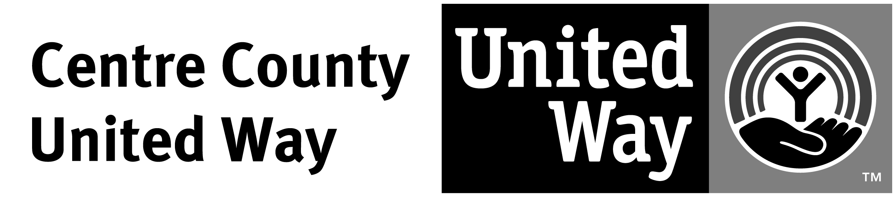

Funds Distribution Philosophy

Centre County United Way (CCUW) will, within the limits of our annual fund raising campaign, fund partner agency programs that address needs necessary to improve lives in Centre County. Funding preference will be given to successful, proven programs with continued and sustainable funding.
Funding preference will be given to programs that address independently identified needs within the Centre County community. Our current priorities are:
  - Children and Youth
  - People in Crisis
  - Employment and healthcare
  - Transportation
  - Shelter Care
Partner agencies will demonstrate good stewardship of program funding by adhering to sound financial management principles, their own policies and procedures and the annual Memorandum of Understanding with CCUW.
Accepted programs will measure the outcomes of their efforts in accordance with a plan to demonstrate concrete, positive results for reasonable costs.

